 | 7.1.22 Editors - 3D Viewport - Header - Surface - Edit mode - Surface menu
Table of content
Detailed Table of content 1
Edit Mode - Surface Menu 4
Transform 4
To Sphere 4
Shear 5
Bend 6
Push/Pull 6
Warp 7
Randomize Transform 7
Move Texture Space 8
Scale Texture Space 9
Set Dimensions 10
Mirror 10
Interactive Mirror 11
X Global, Y Global etc. 11
Snap 11
Snap 11
Operators 12
Spin 12
Duplicate 12
Split 13
Separate 13
Toggle Cyclic 13
Show / Hide 13
Delete 14

Detailed Table of content

Detailed table of content
Detailed Table of content 1
Edit Mode - Surface Menu 4
Transform 4
To Sphere 4
Usage 4
Last Operator To Sphere 4
Factor 4
Mirror Editing 5
Proportional editing 5
Proportional Falloff 5
Proportional Size 5
Connected 5
Projected(2D) 5
Shear 5
Last Operator Shear 5
Offset 5
Axis 5
Axis Ortho 5
Orientation 5
Mirror Editing 6
Proportional editing 6
Proportional Falloff 6
Proportional Size 6
Connected 6
Projected(2D) 6
Bend 6
Push/Pull 6
Last Operator Push/Pull 6
Distance 6
Mirror Editing 6
Proportional editing 6
Proportional Falloff 7
Proportional Size 7
Connected 7
Projected(2D) 7
Warp 7
Last operator Warp 7
Warp Angle 7
Offset Angle 7
Min 7
Max 7
Randomize Transform 7
Last Operator Randomize Transform 7
Amount 7
Uniform 7
Normal 8
Random Seed 8
Move Texture Space 8
Last Operator Move 8
Move 8
Orientation 8
Mirror Editing 8
Proportional editing 8
Proportional Falloff 9
Proportional Size 9
Connected 9
Projected(2D) 9
Scale Texture Space 9
Last Operator Resize 9
Scale 9
Orientation 10
Mirror Editing 10
Proportional editing 10
Proportional Falloff 10
Proportional Size 10
Connected 10
Projected(2D) 10
Set Dimensions 10
Last Operator Set Dimensions 10
New Dimensions 10
Mirror 10
Interactive Mirror 11
X Global, Y Global etc. 11
Last Operator Mirror 11
Orientation 11
Constraint Axis 11
Snap 11
Snap 11
Last operator Snap Selection to Cursor 11
Offset 11
Rotation 12
Operators 12
Spin 12
Last Operator Spin 12
Center 12
Axis 12
Duplicate 12
Last Operator Duplicate 12
Move X , Y , Z 12
Orientation 12
Mirror Editing 12
Proportional editing 12
Proportional Falloff 13
Proportional Size 13
Connected 13
Projected(2D) 13
Split 13
Separate 13
Toggle Cyclic 13
Last Operator Toggle Cyclic 13
Direction 13
Show / Hide 13
Show Hidden 13
Hide Selected 13
Last Operator Hide Selected 14
Unselected 14
Hide Unselected 14
Delete 14
Vertices 14
Segment 14

Edit Mode - Surface Menu

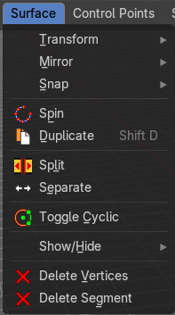
The Surface menu just exists for Surface objects.
Greyed out menu items are not available for surface objects. They are meant for curve objects of type Bezier. Those menu items are not covered here.

Transform


To Sphere
Shapes a selection of objects into the shape of a sphere. The calculation happens with the object origins.
In Object mode this tools requires to have more than one object selected.

Usage

Select the vertices, activate the tool, then drag the mouse in the 3D viewport. In the header you will read the current factor then. Which tells you how close you are towards the sphere shape.


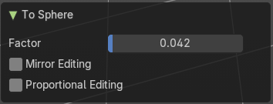
Last Operator To Sphere

Factor
The factor to transform the selection into a shape form.

Mirror Editing
Enable mirror editing.

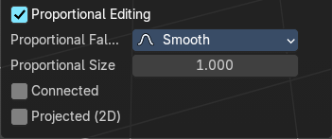
Proportional editing
Enables proportional editing. Activating proportional editing reveals further settings.

Proportional Falloff
Adjust the falloff methods.

Proportional Size
See and adjust the falloff radius.

Connected
The proportional falloff gets calculated for connected parts only.

Projected(2D)
The proportional falloff.

Shear
Shear shears the selection.
In Object mode this tools requires to have more than one object selected.
The shear tool works along a imaginary 2d plane. The shear axis controls if the items are sheared along the x or the y axes of this plane. This is the plane along which the transformation happens. You can shear along the x or the y axis of this plane.
To make things even more complicated, the orientation of this imaginary plane is defined by the Axis and Axis Ortho items below.

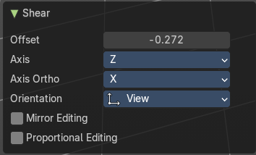
Last Operator Shear

Offset
Adjust an offset.

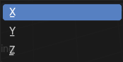
Axis
Defines one axis of the imaginary shear axis plane.

Axis Ortho
Defines the other axis of the imaginary shear axis plane.

Orientation
Choose the orientation for the shear action.

Mirror Editing
Enable mirror editing.

Proportional editing
Enables proportional editing. Activating proportional editing reveals further settings.

Proportional Falloff
Adjust the falloff methods.

Proportional Size
See and adjust the falloff radius.

Connected
The proportional falloff gets calculated for connected parts only.

Projected(2D)
The proportional falloff gets calculated in the screen space. Depth doesn't play a role. When it's in the radius, then it gets calculated.

Bend
Bends the selection.

Push/Pull
It pushes or pulls the object positions relative to the center of the selection.
In Object mode this tool requires to have more than one object selected.

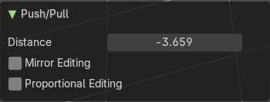
Last Operator Push/Pull

Distance
Adjust the distance of influence of the tool.

Mirror Editing
Enable mirror editing.

Proportional editing
Enables proportional editing. Activating proportional editing reveals further settings.

Proportional Falloff
Adjust the falloff methods.

Proportional Size
See and adjust the falloff radius.

Connected
The proportional falloff gets calculated for connected parts only.

Projected(2D)
The proportional falloff gets calculated in the screen space. Depth doesn't play a role. When it's in the radius, then it gets calculated.


Warp
Warps a mesh selection between two defined points. This also works with curves.

Last operator Warp

Warp Angle
The strength of the warp effect.

Offset Angle
An offset angle to bend side wards.


Min
The start point.

Max
The end point.

Randomize Transform
This tool allows randomizes the positions of the selected vertices.


Last Operator Randomize Transform

Amount
Adjust the amount.

Uniform
The uniform offset distance.

Normal
Align the offset direction to the normals.

Random Seed
The seed value for randomization.


Move Texture Space
This tool relies at the move tool. With the difference that it moves the texture space instead of the object. It has also a very special use case, and just works with a material with a Texture Coordinate / Generated node. And requires to have the shading at Material or Rendered to see a result in the viewport.
In the viewport you will see the UV cage in black color. In the header you will see the values for the current position of the UV cage.
Note that once done and applied, there is no way to reset the UV cage back to zero. When you repeat the operation, then the values will start at 0 again. Even when the UV cage is already offset.


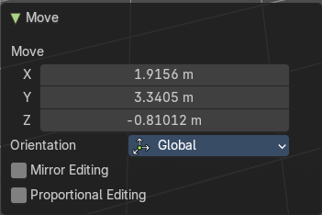
Last Operator Move

Move
Adjust in which directions you want to transform.

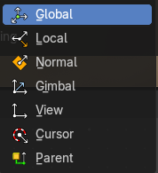
Orientation
Choose the orientation.

Mirror Editing
Enable mirror editing.

Proportional editing
Enables proportional editing. Activating proportional editing reveals further settings.

Proportional Falloff
Adjust the falloff methods.

Proportional Size
See and adjust the falloff radius.

Connected
The proportional falloff gets calculated for connected parts only.

Projected(2D)
The proportional falloff gets calculated in the screen space. Depth doesn't play a role. When it's in the radius, then it gets calculated.


Scale Texture Space
Scale Texture space is similar to the Move texture Space. With the only difference that it scales the UV space instead of moving it.
This tool relies at the scale tool. With the difference that it scales the texture space instead of the object. It has also a very special use case, and just works with a material with a Texture Coordinate / Generated node. And requires to have the shading at Material or Rendered to see a result in the viewport.
In the viewport you will see the UV cage in black color. In the header you will see the values for the current position of the UV cage.
Note that once done and applied, there is no way to reset the UV cage back to zero. When you repeat the operation, then the values will start at 0 again. Even when the UV cage is already offset.


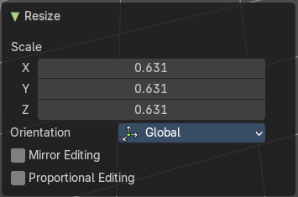
Last Operator Resize

Scale
Adjust in which directions you want to transform.

Orientation
Choose the orientation.

Mirror Editing
Enable mirror editing.

Proportional editing
Enables proportional editing. Activating proportional editing reveals further settings.

Proportional Falloff
Adjust the falloff methods.

Proportional Size
See and adjust the falloff radius.

Connected
The proportional falloff gets calculated for connected parts only.

Projected(2D)
The proportional falloff gets calculated in the screen space. Depth doesn't play a role. When it's in the radius, then it gets calculated.


Set Dimensions
Edit Mode Only!
Normally all scale operations in Bforartists are relative to the current selection and dimensions. And you always start with a relative value of 1.
Set dimensions allows to scale mesh selections in absolute world values. No matter how the initial values are. The new values gets set in the Last Operator.
Set dimensions is an add-on. You can turn it off in the add-ons section of the user preferences when you want.

Last Operator Set Dimensions


New Dimensions
When you activate the tool then you will see the world coordinates of the selection. Change the values to other world coordinates.

Mirror
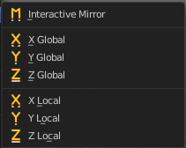
Mirror mirrors the selected geometry along the defined axis.

Interactive Mirror
Mirror by hotkeys. You activate the tool, type in x for x global for example, or x x for x local. And the selection gets mirrored

X Global, Y Global etc.
Mirrors the selection around the chosen axis.

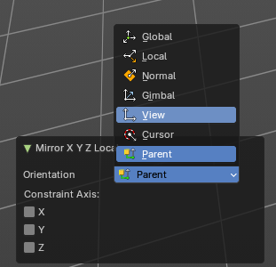
Last Operator Mirror
The Last Operator Mirror panel gives you tools to adjust the mirror action.


Orientation
Orientation is a drop-down box . Choose the type of orientation for the mirroring action.

Constraint Axis
Constraint Axis gives you again the possibility to define the mirror axis. You can choose more than one axis here.

Snap


Snap
Choose several methods to snap one element to another. The menu items should be self explaining.

Last operator Snap Selection to Cursor
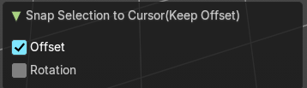
Some snap operations shows a last operation panel, some not.

Offset
If the selection should snap as a whole, or if each individual element of the selection should snap.

Rotation
If the selection should be rotated to match the cursor.

Operators

Spin
Extrude selected boundary row around the pivot point and the current view axis.

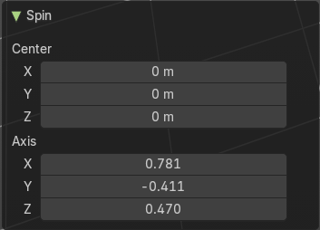
Last Operator Spin

Center
The center of the spin.

Axis
The axis in global view space.

Duplicate
Duplicates the current selection. This can be a single control point or a whole curve.
The copy sticks to the mouse until you release it. A Right click while moving will reset the position of the duplicate. The duplicated part will be part of the same object.
When you drag the duplicate around you will see the position values in the header.

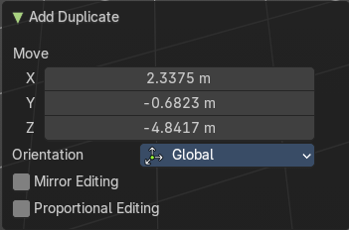
Last Operator Duplicate

Move X , Y , Z

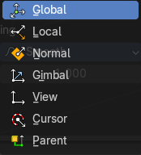
Orientation
Choose the orientation.

Mirror Editing
Enable Mirror Editing.

Proportional editing
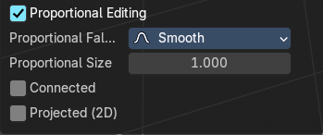
Enables proportional editing. Activating proportional editing reveals further settings.

Proportional Falloff
Adjust the falloff methods.

Proportional Size
See and adjust the falloff radius.

Connected
The proportional falloff gets calculated for connected parts only.

Projected(2D)
The proportional falloff gets calculated in the screen space. Depth doesn't play a role. When it's in the radius, then it gets calculated.

Split
Splits the curve at the selected control point(s). You need to select two control points to select the segment between it.

Separate
Separates the selected control points, and creates a new curve object out of it. You need to select two control points to select the segment between it.

Toggle Cyclic

Toggle Cyclic closes or opens the curve.

Last Operator Toggle Cyclic

Direction
Direction is a drop-down box. Choose the direction in which the curve gets closed.


Show / Hide

Show Hidden
Makes all curve geometry in the scene visible again.

Hide Selected
Hides the selected curve geometry.


Last Operator Hide Selected

Unselected
Hides the not selected curve geometry.

Hide Unselected
Hides the not selected curve geometry. The selected geometry stays visible.

Delete

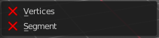
Vertices
Dissolves the selected vertices. When removing vertices in between then the curve stays intact and connected.

Segment
Removes the segment between the selected vertices.

